

**University of Turkish Aeronautical Association**

**Faculty of Engineering**

**Department of Industrial Engineering**

**Senior Design Project**

**Project Title : Process Improvement & Plant Design in Production Facility**

**Students Name :**

* **OĞUZHAN MAZLUMOĞLU – 140145801**
* **ÖMER AYBERK LODİ – 130145019**
* **ÖMER KÜNYELİ – 140145028**
* **Advisor : Yrd. Doç. Dr. Hasan Umut AKIN**

**Date Submitted : 10.04.2020**

**ANKARA 2020**

**Process Improvement & Plant Design in Production Facility**

**Oğuzhan MAZLUMOĞLU -** [**oguzcmc@gmail.com**](mailto:oguzcmc@gmail.com) **0536 525 48 31**

**Ömer Ayberk LODİ -** [**ayberklodi@gmail.com**](mailto:ayberklodi@gmail.com) **0534 475 44 48**

**Ömer KÜNYELİ -** [**omerkunyeli@gmail.com**](mailto:omerkunyeli@gmail.com) **0531 228 27 78**

**Senior Design Project Advisor : Yrd. Doç. Dr. Hasan Umut AKIN**

**Company: MAPSAN A.Ş.**

**Company Advisior: Murat PAZARBAŞ Industrial Engineer**

**Bachelor’s Degree, Industrial and Systems Engineering**

**May 2020**

**Abstract:** The purpose of this study is to replan the complex order within the facility depending on the product. The reason for this is to use the working section in the facility more efficiently and economically. There are analysis and graphics used in this improvement. These are SWOT analysis, Gantt Chart, Pareto Analysis, FishBone diagram, Product Production Tree diagram, Work Breakdown structure table. Finally, the ALDEP algorithm is used to complete the project. As a result of the information provided by the company, the safest and most efficient design has been created. We plan to present and explain to the factory manager how the design has helped the company. The biggest factor in this design is to reduce time losses within the facility. By making the machine layout and working area more efficient. We aim to be able to move comfortably to employees or during moving.

**Keywords:** Layout Planning and Design, Automated Layout Design Program(ALDEP), Manufacturing Facilities Design, Production and Operation Analysis.

**SUMMARY**

This study aimed to increase productivity by reducing the costs and losses of the factory and company working in the production area. It is also aimed to improve the conditions of working workers. The distances and relationships between the stations in the production area of ​​the 'Asansörlü Çeki Komple' product in MAPSAN are quite irregular in the current order. Some determinations were made with the methods and methodologies described in the report. The moving times of the products between the stations are very high. At the same time, due to the very long distances, hand-carried products cause more fatigue and loss of time for the employees. For this reason, a product based production line was designed in this project. In this way, it is aimed to significantly improve the transportation times of the products between the stations and to wear the employees less. Firstly, the product production tree was created. Then, work time studies were carried out in this product production tree. The production times of the products and the transportation times between the stations were determined. Later, Pareto Analysis determined the stations that form the basis of the problems and focused on these stations. Microsoft Excel and draw.io programs have been used. The movements of the products in these stations are determined from the current factory map. It was decided to create a production line for these stations. Automated Layout Design Program (ALDEP) was used for this. With this method, the relationships between stations are examined and graded. At the same time, the required production areas for the stations were determined. After determining the ratings and required areas between the stations, it is aimed to create new lines by processing these data correctly. With the ALDEP method, it is aimed to create a more efficient product-based production line.

İçindekiler Tablosu

Abstract………………………………………………………………………………………2

SUMMARY……………………………………………………………………………………3

1.INTRODUCTION…………………………………………………………………………6

2. METHODS…………………………………………………………………………………6

2.1. Data Collection - 6 -

2.2 Methodology and Determinations - 9 -

2.3. Solution Aproach - 12 -

3. DISCUSSION

3.1 ALDEP Model - 20 -

3.1.1 Department selection - 20 -

3.1.2 Department placement and sweep pattern - 20 -

3.1.3 Activity Relationship Chart (REL Chart) - 21 -

3.2 ALDEP Problem Solution - 21 -

4. CONCLUSION

5. RECOMMENDATIONS

6. REFERENCE

1. INTRODUCTION

The company that we started the senior design project produces tractor parts. The important part of this factory for us is that they have been closed for a while and have been re-manufactured. As a group, our prioritized problem was errors in machine layout and layout. When we did a work and time study to see time losses, we saw the wrong places and bottlenecks. Factory design, layout and personal planning have a huge impact on the quality, efficiency and competitiveness of the company in many ways. There are factors where facility layout is important. It is a method that deals with and implements the layout of machines, relations in the production flow, general factory design and layout, personal planning. As a result of our observations and examinations, we first conducted a work and time study. Here we tried to analyze how workers work, whether there are machine problems, and started analyzing. As a result of the analyzes, we learned that we should make a new facility arrangement. Our aim is to improve the communication between the employees when the design is finished, and to make it more convenient and easier to move. We plan to reduce these losses due to the development plan that we will consider in product flow charts and the fact that the products go into too many processes and the connections between these processes are slow. We found that this is the type of analysis that we will use. in this analysis we will be able to describe the relationship scheme and its function. After making definitions, we create the relationship chart. These procedures will benefit us in establishing optimum placement. The method to be used in this project will be automated layout design program (ALDEP). ALDEP is an algorithm developed by IBM. It uses the basic data about the facilities and creates a layout by placing the order one after another using the relationship information between the departments. Our aim is to use this facility more efficiently.

2. METHODS

Methods are very important for projects. They almost form the backbone of the projects. We will use some methods to realize our project. These will be in determining how the product in our project is produced, the stages of the production of the product, problems in the production of the product, bottlenecks. We will also use some methods of solving these problems. These methods are SWOT Analysis, Pareto Diagram, Product Production Tree, Gantt Diagram, Fishbone Diagram and Automated Layout Design Program(ALDEP). As a result of these studies, our expectation from the project is the realization of improvements.

## 2.1. Data Collection

First of all, we must determine all the stages starting from the raw material to the final product. The reason we do this is to see the big picture. Later, by examining the big picture and applying some methods, bottlenecks and problems in production will be identified. For this reason, we created the product production tree. You can see it next page the Figure-1 below.

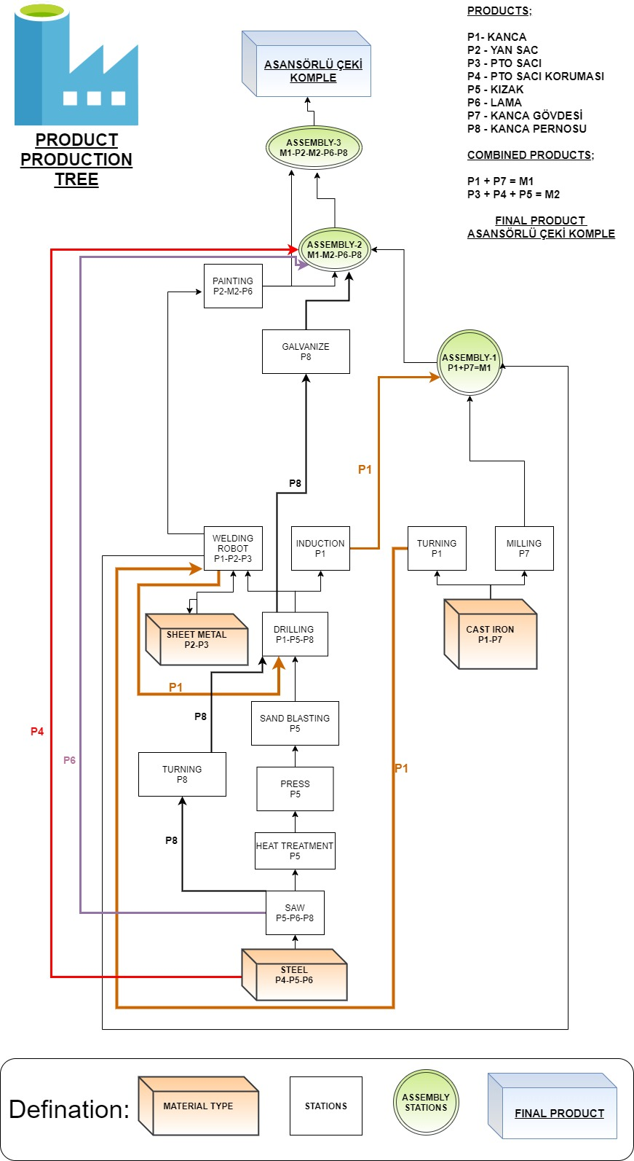 ***Figure-1***

We made time measurements by doing a work-time study at the stages we set in the product tree.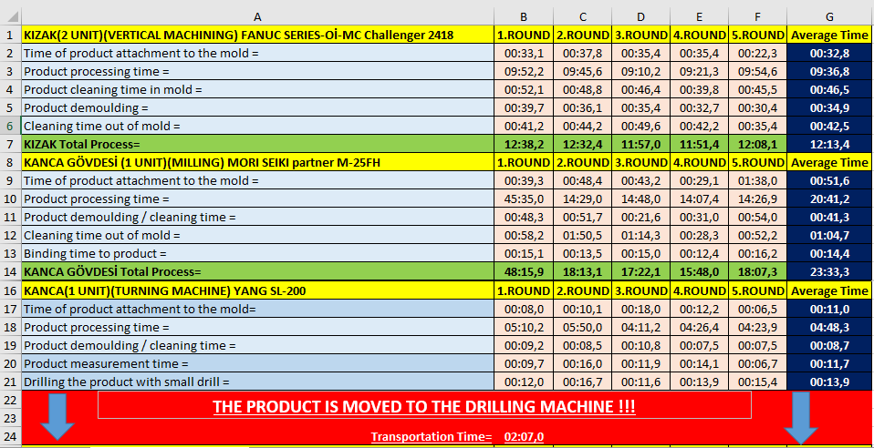 As a result of the time measurements we made on the production line of the factory; We obtained the data in Figure-2 and Figure-3 regarding the production line. Using these data with the help of our methodologies, we reached the results in Figüre-4. Here we have benefited from Microsoft Office applications Microsoft Excel.

**Figure-2**

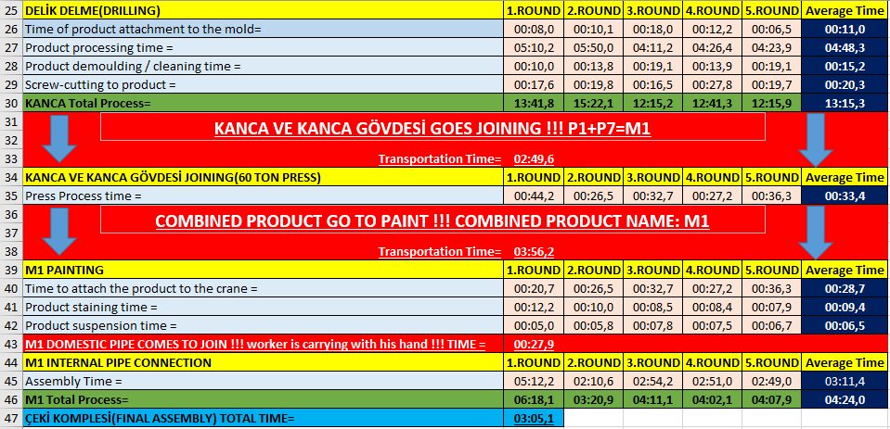

**Figure-3**

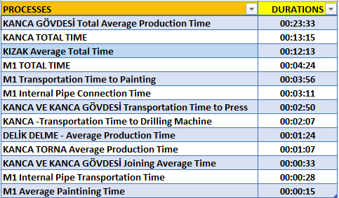

**Figure-4**

**Microsoft Excel Data:**



## 2.2 Methodology and Determinations

Pareto analysis is a bar diagram used to separate important causes of a problem from more complex, less important reasons. Application is also a method used in team works.

In Pareto analysis, there is a rule known as 80/20. Accordingly, in many cases, 80% of the results are caused by 20% of the causes.

By applying this method in our project, we identified the stations and bottlenecks where there were major problems. You can see the Figure-5 below. Then we applied some scientific methods to improve these bottlenecks and processes at the stations.

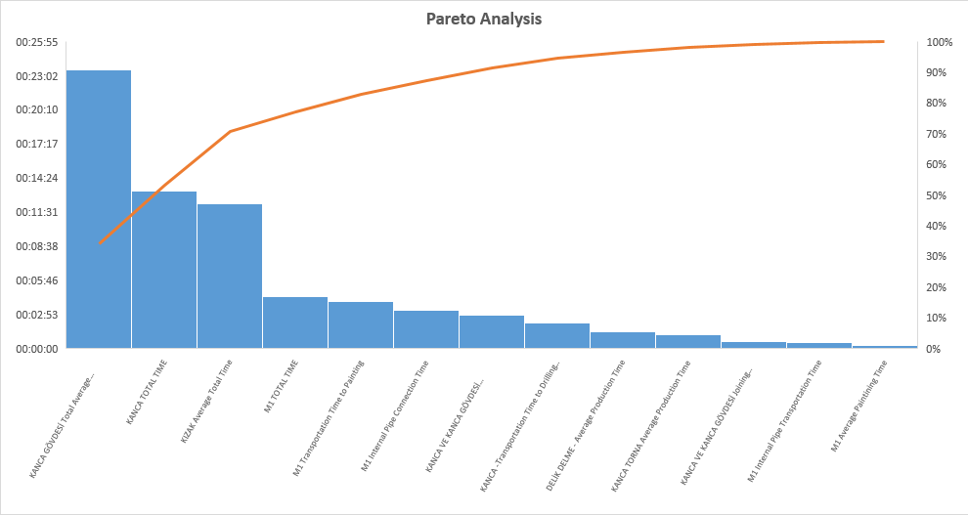

**Figure-5**

**Microsoft Excel Data:**



Also, the fishbone diagram or Ishikawa diagram is a cause-and-effect diagram that helps managers to track down the reasons for imperfections, variations, defects, or failures. We made a fishbone diagram for our project in appendix page. You can see the Figure-6 below.

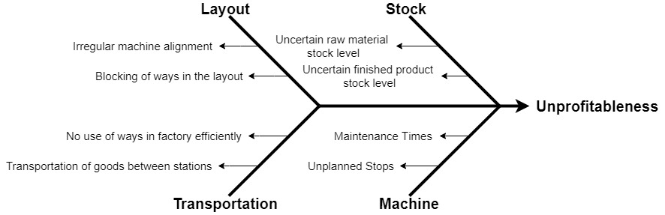

**Figure-6**

As a result of work-time study and pareto analysis, problematic stations were identified. The time measurements at those stations are shown in the Figure-7 below.

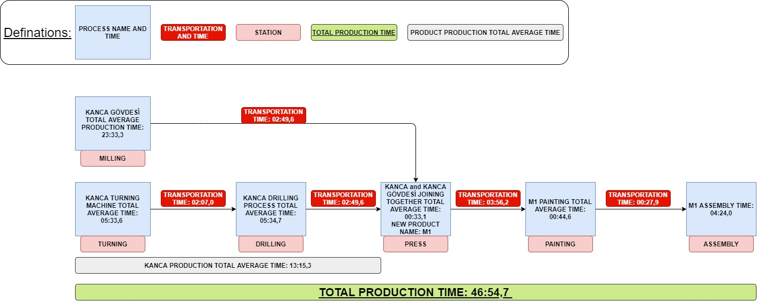

**Figure-7**

As shown in these measurements, the transportation time of the product in the factory is very large and it causes bottlenecks and losses in the system. The movements of the product in the factory are shown in Figure-8 below.

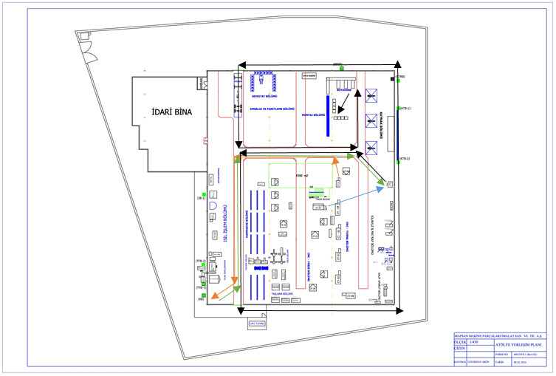

**Figure-8**

Products that come as raw materials are first processed in turning and milling stations. The parts coming out of turning station follow the path indicated by the orange arrows to the drill station and drill. Afterwards, they move on the path indicated by green arrows and come to the press process. In the parts coming out of the milling station, it comes to the press operation with the path indicated by the blue arrow. Here, these two types of products are combined into a single product. After this process, the combined product comes to the painting station by following the path indicated by the black arrows. After painting, our product follows the path indicated by black arrows and arrives at the final station, the assembly station. And here the final product is completed. You can see all these steps in Figure-8.

Here, we want to improve, to minimize the path of the product within the factory, to create a production line according to the product and to eliminate transportation costs and losses. For this situation, we will use the Automated Layout Design Program(ALDEP) method.

## 2.3. Solution Aproach

Automated Layout Design Programe(ALDEP) was developed at IBM and originally offered by Seehof and Evans. ALDEP is primarily an enterprise algorithm. However, due to the evaluation process used in accepting or rejecting a given placement scheme, it can also be considered as a development program. ALDEP designs the layout without the need for an existing layout, such as layout layout programs. However, it also compares solutions that emerge similar to the method used in a development algorithm.

Although ALDEP has many different application forms, this section will describe the random selection method. The random selection method of ALDEP is to develop a layout design by briefly selecting a section randomly and placing it within the placement order.

A relationship diagram is created using the codes in the relationship table. The relationship codes are given in the table below.

|  |  |
| --- | --- |
| **Code** | **Defination** |
| **A** | Absolutely necessary that these two departments be next to each other |
| **E** | Especially important |
| **I** | Important |
| **O** | Ordinary importance |
| **U** | Unimportant |
| **X** | Closeness undesirable |

The numerical values ​​that ALDEP assigns to proximity degrees are as follows (Francis, 1974):

**A = 43= 64 | O = 40**

**E = 42 = 16 | U = 0**

**I = 41= 4 | X = -45 = -1.024**

Then, the relationship table is examined and placed in a section layout that shows a high degree of affinity (For example (A or E). This process is continued until all sections are placed or there are no sections suitable for placement of the sections placed. If there are such sections, one of them is randomly selected and placed in the order The selection process continues until all the sections are placed in the order The total score of the placement order is determined by adding the numerical values ​​given for the adjacent sections according to their degree of proximity.

ALDEP is capable of realizing solutions up to 63 sections or actions and can realize multi-layered layouts up to three floors. In addition, it is possible to add some restrictions to the solution. For example; The layout can be designed around passages, elevator shafts, stairwells, g, r, jobs and existing sections.

The required inputs for ALDEP can be listed as follows:

* Length, width and space requirements for each floor,
* Scale of the implanted projection,
* Number of sections in the layout,
* Number of layouts that can be derived,
* The minimum score required for an acceptable placement order,
* Smallest section preference,
* Relationship table for departments,
* The layout and dimensions of the restricted areas for each floor.

It is also necessary to know the building boundaries, as the length, width and area requirements must be determined for each floor. If a new design is placed in the existing facility, the boundaries of the building will be the boundaries of the new facility. When the design is not limited to the existing facility, a preliminary work is required to determine the desired building boundaries.

ALDEP is designed to avoid boundaries that make extreme zigzags using the vertical analysis method in placing the sections. Basically, the placement area area is filled using certain long and wide vertical stripes equal to the depth of the placement layout. The method can be animated considering a strip roll of a certain width. One length of the strips is one slice of the roll. The area of ​​the strip corresponds to the area of ​​the section. The ribbon is placed in the layout. When the length of the strip is greater than the depth of the insertion arrangement, the strip is cut and the increased portion is placed next to the strip piece previously placed. The analysis model used is basically as shown in Figure-9. Despite all the efforts made to avoid the irregular section boundaries, such situations are still encountered.

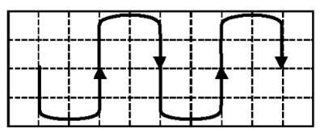

**Figure-9**

Proximity relationships between stations, which we previously detected were bottlenecks. These relationships were determined by taking information from the observations made, employees and authorized engineers. The detected relationships are shown in Figure-10 below.

***Figure-10***

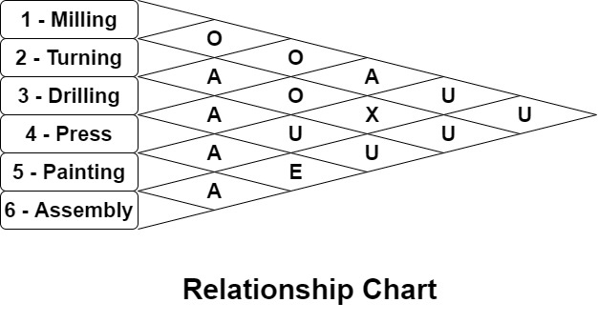

After that we made Activity Relatioship Worksheet. Here, all the relations that the stations have are identified and written. You can see it in Figure-11.

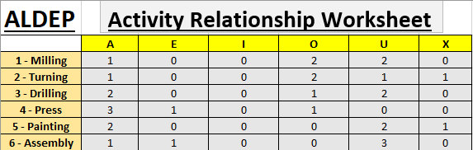

***Figure-11***

First of all, stations with 'A' proximity relation are selected. And these are examined within themselves. The station with greater proximity relationship 'A' is selected and becomes the first station of the proximity relationship sequence. If 'A' proximity relations are equal, 'E' proximity relations are checked. If they are equal, 'I' proximity relationships are checked. With this rule, you can go by looking towards other proximity relationships. In this order, stations are selected and added to the order of proximity relations.

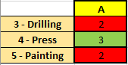

***Figure-12***

Here our first station for sequence of proximity relationships is 4 - Press. Because it has biggest A relationship value. You can see it in Figure-12.

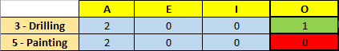

***Figure-13***

Our second station is 3 - Drilling. And, our third station is '5 - Painting'. For now, our sequence of proximity relationships; ‘4 - 3 - 5 –‘. You can see it in Figure-13.

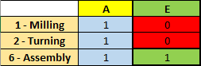

***Figure-14***

Our fourth station is '6 - Assembly'. For now, our sequence of proximity relationships; 4 - 3 - 5 - 6 -. You can see it in Figure-14.

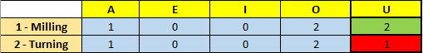

***Figure-15***

Our fifth station is '1 - Milling'. And, only '2 - Turning' station remains. It is the sixth station. Our sequence of proximity relationships; '4 - 3 - 5 - 6 - 1 - 2'. You can see it in Figure-15.

We get Sequence of Proximity Relationships after all these processes. You can see it in Figure-16.



***Figure-16***

Now, the relationship between station '4 - Press' and other stations will be examined and a new layout vector will be found. You can see it in Figure-17.

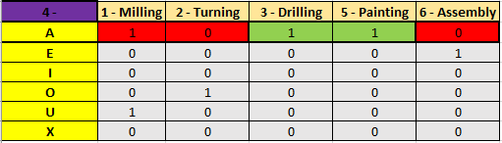

***Figure-17***

There is equality here. Proximity relations A of stations 3 and 5 are equal. In order for this equality to deteriorate, we have to look at their order in the relationship of intimacy. Station 3 was ranked earlier than station 5 in order of proximity relationship. As a result, we choose station number 3. Our second station is '3 - Drilling'. And we take away station number 3 from the table. This process will continue in the same way for other stations. For now, our layout vector is; '4 - 3 -'. You can see it in Figure-17.

Now we will look at the proximity relations between station 3 and other stations. We will do the same for every station added to the layout vector. You can see it in Figure-18.

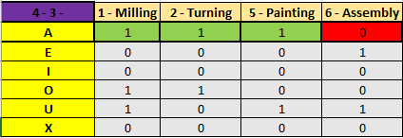

***Figure-18***

Again there is a equality here. So we have to look their sequence of proximity relationships. We found before. Station 5 is before station 2 and station 1. So, our third station is '5 - Painting'. For now, our layout vector is; '4 - 3 - 5 -'. You can see it in Figure-18.

Now we will look at the proximity relations between station 5 and other stations. We will do the same for every station added to the layout vector. You can see it in Figure-19.

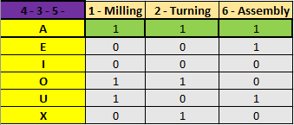

***Figure-19***

There is a equality here. So we have to look their sequence of proximity relationships. Station 6 is before station 2 and station 1. So, our fourth station is '6 - Assembly'. For now, our layout vector is; '4 - 3 - 5 - 6 - '. You can see it in Figure-19.

Now we will look at the proximity relations between station 6 and other stations. We will do the same for every station added to the layout vector. You can see it in Figure-20.

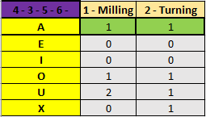

***Figure-20***

Again there is a equality here. So we have to look their sequence of proximity relationships. Station 1 is before station 2. So, our fifth station is '1 - Milling' and our sixth station is '2 - Turning'. Our layout vector is; '4 - 3 - 5 - 6 - 1 - 2'. You can see it in Figure-20.

Finally, we get the Layout Vector. You can see it in Figure-21.



***Figure-21***

You can find all these stages, steps and processes in the following Microsoft Excel file.

**Microsoft Excel File:**



Use ALDEP procedure to determine the layout vector, construct and evaluate the layout for the facility based on the relationship chart and the station dimensions given below. You can see them Figure-22, Figure-23. The dimensions of the facility are 9x9. Use the sweep width of 3. One sweep width equals 1 M². The closeness values: A=64, E=16, I=4, O=1, U=0, X=-1024.

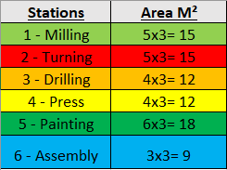

***Figure-22***

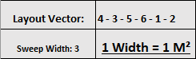

***Figure-23***

Adjacency score relations of the stations are determined from left to right. You can see it in Figure-24.

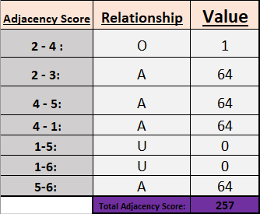

***Figure-24***

Layout construction. It is vertical sweep pattern. On the other hand, the production should be adjusted so as not to disturb the order. Because placement is made according to the product in this form of production. You can see it in Figure-25.

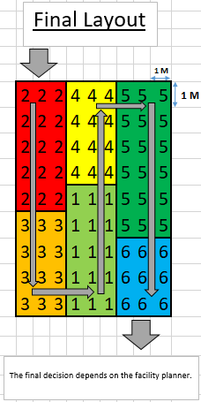

***Figure-25***

You can see total area for this layout, sequence and adjacency score in Figure-26.

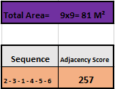

***Figure-26***

You can find all these stages, steps and processes in the following Microsoft Excel file.

**Microsoft Excel File:**



3. DISCUSSION

In this study we observed factory and get feedback from the engineers to understand the problem and find a way to solve the problem with best possible applicable solution. After decide the problem, we need to work with right methodology. In this section, will be described why ALDEP (Automated Layout Design Program) is the right method to solve this kind of layout problems.

Before deciding which layout will be appropriate for a new and organized facilities, first study should be the pattern of flow. The simplest flow is straight- line flow, encountered on an assembly line. There are other patterns include serpentine flow, circular flow, U flow, L flow and S flow. Another issue is desirability or undesirability of locating units near each other. For example, a painting shop has to be separate from any other department with can cause spark to avoid an accident.

For large factories or facilities, determining the best layout manually is impractical. There are several computerized layout techniques available to assist us with this function. They are CRAFT, COFAD, CORELAP, PLANET and ALDEP. All of these techniques are intended for the share the objective of minimizing materials handling costs. In this study we examined that the one suited more than others which is ALDEP.

## 3.1 ALDEP Model

ALDEP is a construction layout. It does not need any initial layout so we can start our model from scratch. It requires the area of each departments and the relationship between these departments based on Activity Relationship chart (REL chart) and sweep width.

## 3.1.1 Department selection

i. First department selected randomly.

ii. Out of those departments select the one which has ‘A’ relationship with the first

one from REL chart or (‘E’, ‘I’ etc. minimum level of importance is determined by

user)

iii. If no such department exists it selects the second one completely randomly

iv. The selection procedure is repeated until all departments are selected (Always search for the department having relationship last one placed in the layout – not all).

## 3.1.2 Department placement and sweep pattern

i. Starts from upper left corner and extends it downward

ii. Sweep width is determined by user

iii. If minimum requirements met, it prints out the layout and the score is given

iv. The layout with highest score (closeness rating) is selected as solution.

## 3.1.3 Activity Relationship Chart (REL Chart)

A relationship diagram that provides a visual means to determine the intensity of flow between processes. Activity relationship diagram shows the relationship of every department, office, or service area with every other department and area. In order to establish this relationship, we use closeness code to “WEIGH” the decision. Refer *Table 1* for REL chart.

## 3.2 ALDEP Problem Solution

|  |  |
| --- | --- |
| **Code** | **Defination** |
| **A** | Absolutely necessary that these two departments be next to each other |
| **E** | Especially important |
| **I** | Important |
| **O** | Ordinary importance |
| **U** | Unimportant |
| **X** | Closeness undesirable |

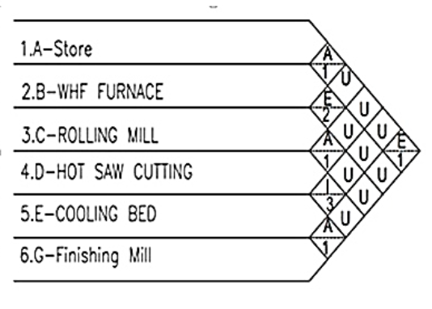

**Table 1:REL Chart**

As we see in *Table 1*, Activity Relationship Chart prepared and will be used to determine the departmens’ order as in *Table* *2.*

**Table 2:Relationship process diagram**

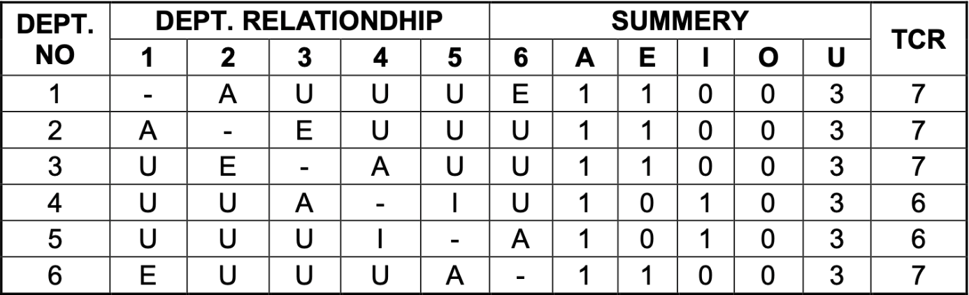

ASSUME:

* TCR (TOTAL CLOSENESS RATING) A=4, E=3, I=2, O=1, U=0
* 1 grid = 84 m2
* Sweep width = 4

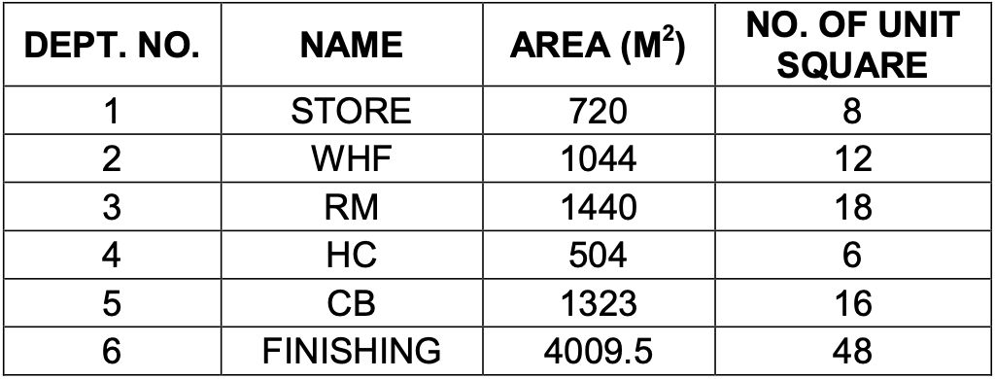

**Table 3: Space Relationship Table**

**Iteration 1:** Refer to *Table 4* for layout modification by Iteration 1 of ALDEP method.

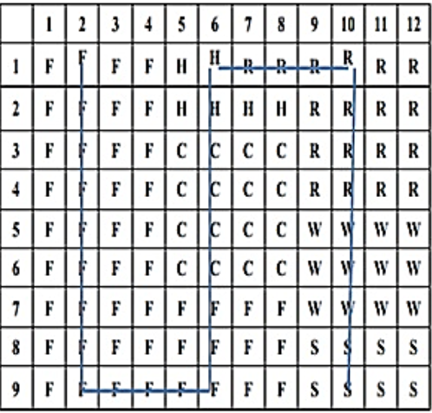

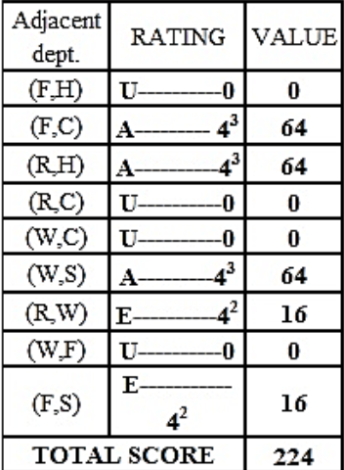

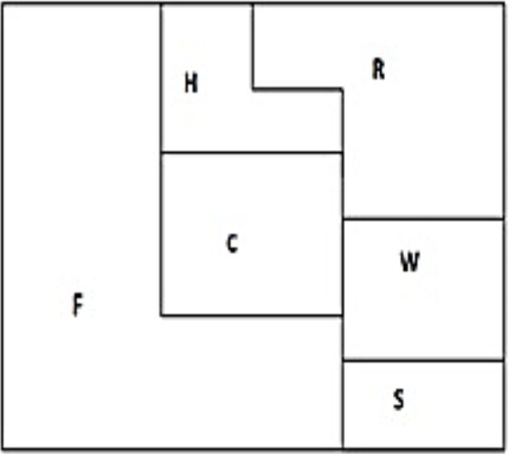

**Table 4:Layout for Iteration 1 by ALDEP method**

**Iteration 5:** Refer to *Table 5* for layout modification by Iteration 5 of ALDEP method.

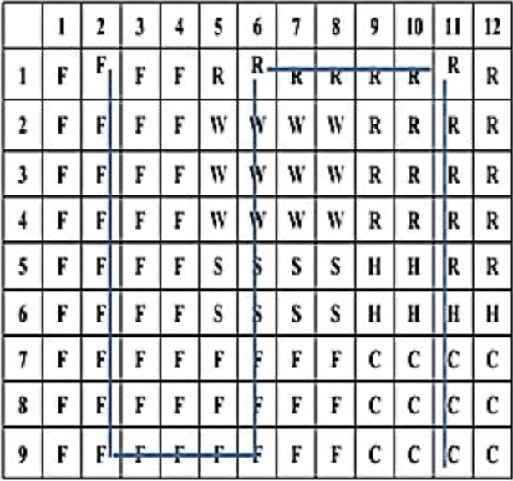

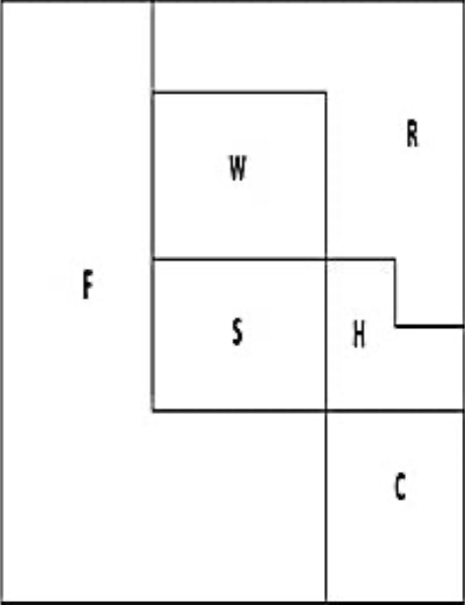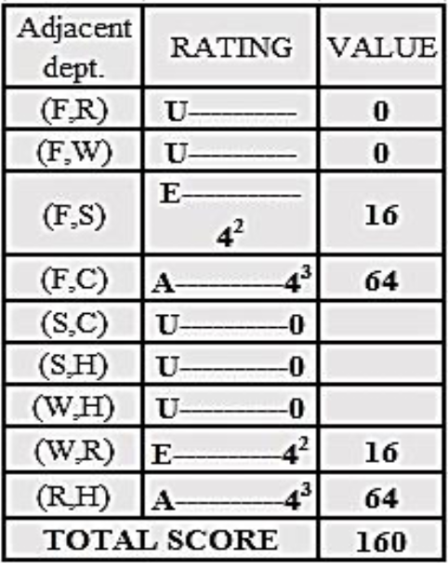

**Table 5: Layout for Iteration 5 by ALDEP method**

**Iteration 6:** Refer to *Table 6* for layout modification by Iteration 6 of ALDEP method.

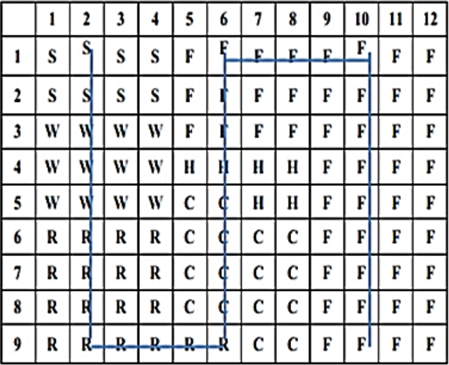

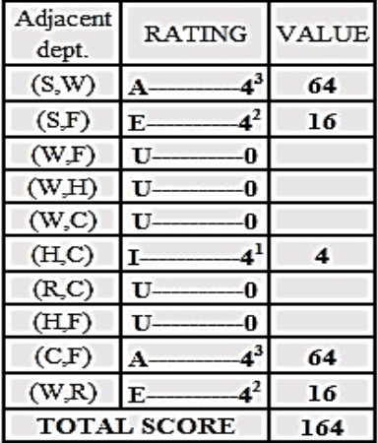

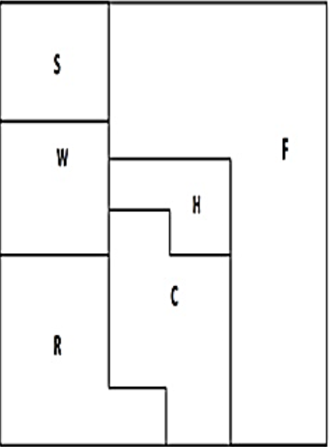

**Table 6: Layout for Iteration 6 by ALDEP method**

After these iterations we find out that the biggest Total Score is 224 in *Iteration 1* offers best solution compared to others. The sequence for this is mentioned in *Table 7*. This iteration is selected compared to other iterations due to reason that it is not affecting the flow of the process.

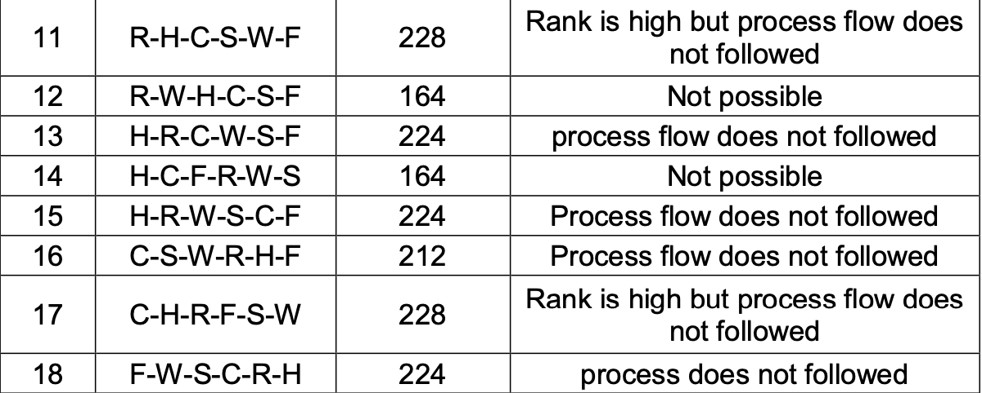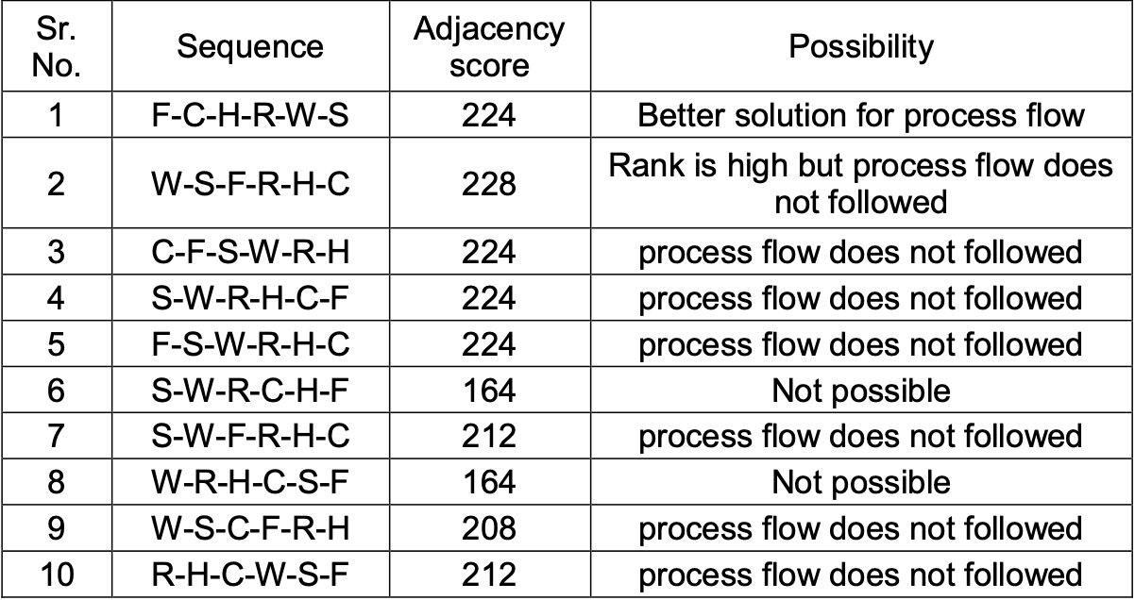

**Table 7: Different possible solutions by ALDEP**

After these iterations the final layout is given in *Figure 8*.

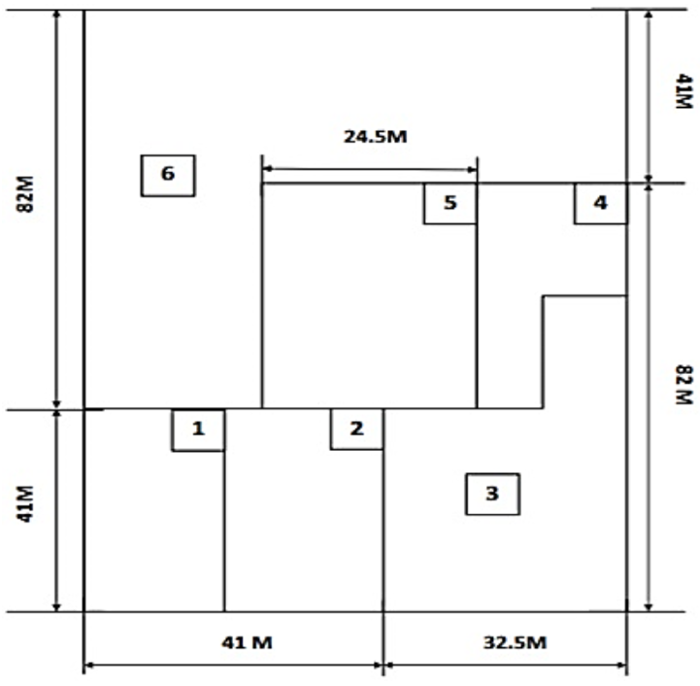

*Figure 8: Proposed Final Layout by ALDEP method*

4. CONCLUSION

We first searched for a problem that we could improve at the factory, and after finding it, we collected the necessary data. We investigated how we can use the data we find and what we can improve. As a result of our research, we decided that the best solution is the ALDEP method.

Operational Research is important for many industries. One of the most important things to consider when starting production is the layout. In the discussion section we observed that ALDEP method is provide an efficient and cost-effective solution for factories and facilities that requires layout planning. As we mentioned before there are many different techniques that useful for layout planning but ALDEP technique is using from companies that needs new layout.

5. RECOMMENDATIONS

In this study, efforts were made to find problems. In order to reach a result in line with the data obtained from the studies, researches were conducted. We concluded that these researches are also on the importance and efficiency of facility design. We have acted according to the information we received in the analyzes made after the literature surveys were conducted. In Pareto analysis, we saw which piece is important and effective than others. According to this analysis, it was easier for us to prepare the work flow chart and add data about when the parts were assembled or the duration of the machines used. From these results, after the analysis, we started to learn how to write code about the plant design, what matrix we should do, what program we can use, for the new placement layout. In the data we obtained, it was a problem for us that the area used to carry products or parts within the factory was not efficient. One of the first problems we saw seemed to have been placed in a vacant place of the machine or device purchased. We have seen bottlenecks in problematic areas detected. For example; In the formation of bottlenecks, distances between communication and processes were observed. As a result, we could see that more production would be available for employees in a shorter time if a design had already been made and placed regularly. It can be designed for a better factory management and increases productivity.

Reference:

* Stephens, M. P., & Meyers, F. E. (2014). Manufacturing Facilities Design & Material Handling. Ashland: Purdue University Press.
* Sule, D. R. (2009). Manufacturing facilities: location, planning, and design. Boca Raton: CRC Press.
* Karadede, Y. , & Çalışkan, S. , Önder, H. H. , (2016). Layout Designing with Mat – Layout Software That is New Method and a Example Application.
* Ak, R. , (2009). İş Yeri Düzenleme Algoritmalarının İncelenmesi ve Bir Fabrika Uygulaması (Yüksek Lisans Tez).
* Nahmias, S., & Olsen, T. L. (2015). Production and operations analysis. Long Grove, IL: Waveland Pr.
* Production and Operations Analysis 7th-Edition - Steven Namias